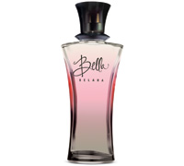OCTOBER SPECIAL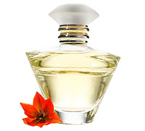
Bella $34.00 Journey $36.00
Buy One Fragrance or Cologne
Get Your Second One for ½ Price
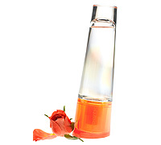Shop today and purchase a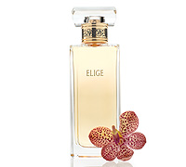
Velocity $28.00 Elige $$40.00
beautiful Mary Kay fragrance as a gift and then select another at ½ price!!!
You can keep it for yourself or give it to that someone special at the Holidays, you decide!
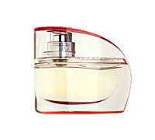Shop 24/7 @ www.marykay.com/margiwhitworth 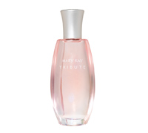Affection $50.00 Tribute $40.00
Or call at 816-246-7174 to set up a Consultation time with me!
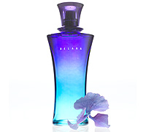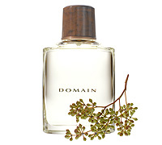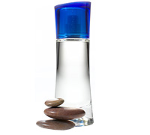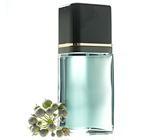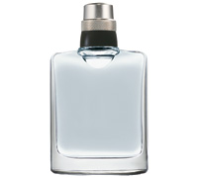
Belara $34.00 Domain $34.00 Velocity $28.00 Tribute $25.00 High Intensity $38.00
Fragrance Personality Quiz
_____1. Do you appreciate the beauty of life?
_____2. Are you a luxury-loving girl?
_____3. Are you always on the go and loving every minute?
_____4. Are you young or young at heart?
_____5. Are you dynamic, active and involoved in the world around you?
_____6. Do you like glamour, grace and style?
Check which one best describes YOU. Then look at the back to find the fragrance that best suits your personality?
Answers For Her

1. Bella Belara Parfum – The exuberant fruity floral captivates immediately.

2. Affection Eau de Parfum – A modern oriental chypre that awakens the senses.

3. Belara Eau de Parfum – A perfect balance of fresh, luminous floral and creamy warm notes.

4. Velocity Eau de Parfum – A euphoric fruity floral that will turn your world upside down.

5. Elige Eau de Parfum – A sheer oriental blend with exotic wood undertones.

For Him

MK High Intensity Cologne – Warm, sophisticated intensity.

Domain Cologne – Clean outdoor freshness.

Tribute for Men Cologne – Dry,smoky, woody.

Velocity for Him Cologne – Energizing mountain air and woods.

